Capture the Flag
Grade 3
Standard MAFS.3.NBT.1.1
Due September 25, 2015
Name ______________________________ Teacher ______________

George has four numbered cards. The cards are shown below:

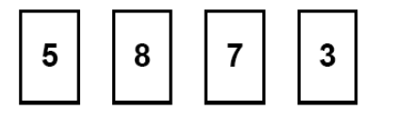

- What order could George place the numbers so that the number would be closest to 4000?

- What is the largest number George can make?

- Explain how you know this is the largest number you can make.

